**Phase 9: Reporting, Dashboards & Security Review**

In this final configuration phase, the focus was on data analysis and strengthening security to ensure the application was both insightful and secure.

**Step-by-Step Process:**

1. **Creating Reports:** To analyze adoption trends, a custom report was built using the Report Builder. The report was designed to group all pets by their current status (e.g., Available, Adopted), providing key insights into the shelter's inventory and operations.
2. **Building Dashboards:** The data from the report was then visualized on a "Shelter Overview" dashboard. A donut chart component was added to give shelter admins a quick, at-a-glance view of the pets' status breakdown, making the data easy to understand.
3. **Conducting a Security Review:** A comprehensive security and access control review was performed. This involved double-checking the permissions on the Guest User Profile for the public portal and the custom "Volunteer" profile to ensure all users had the correct level of access and the application was secure.

* **Security permissions**

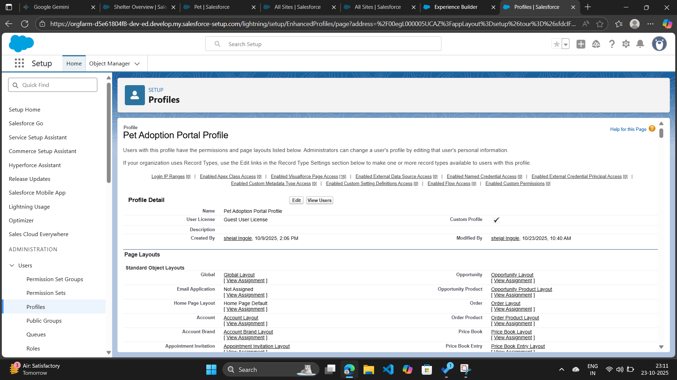

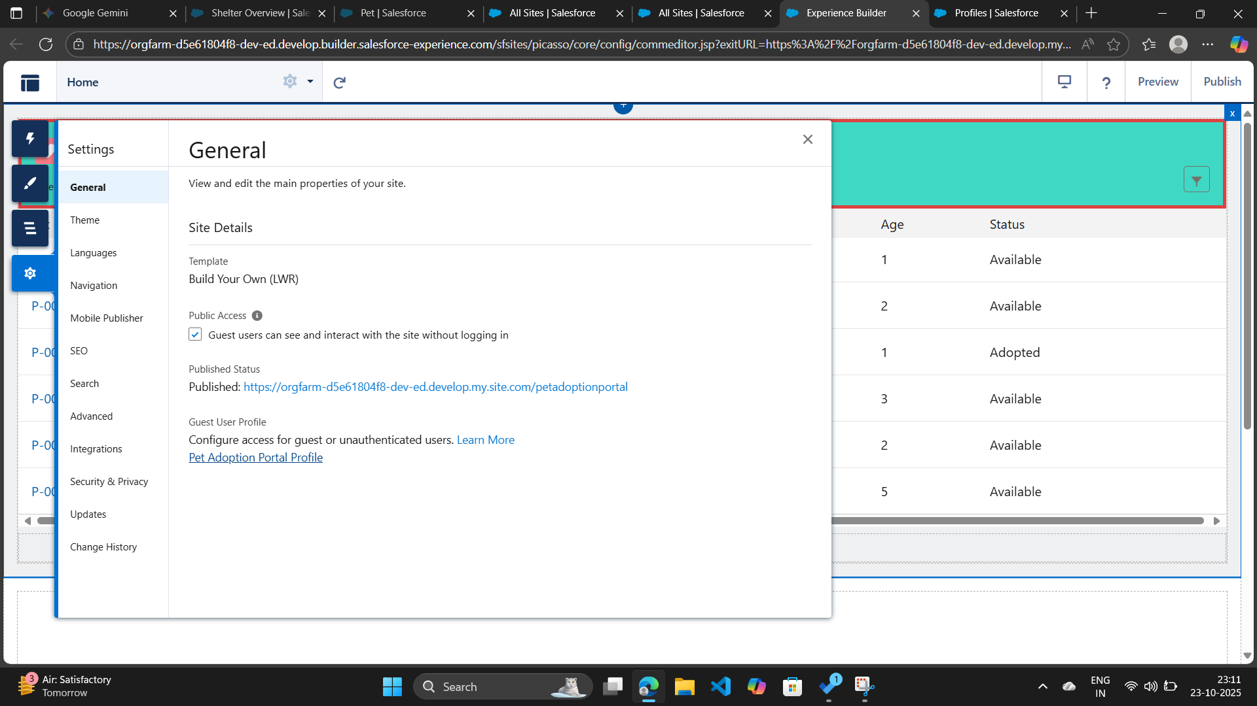

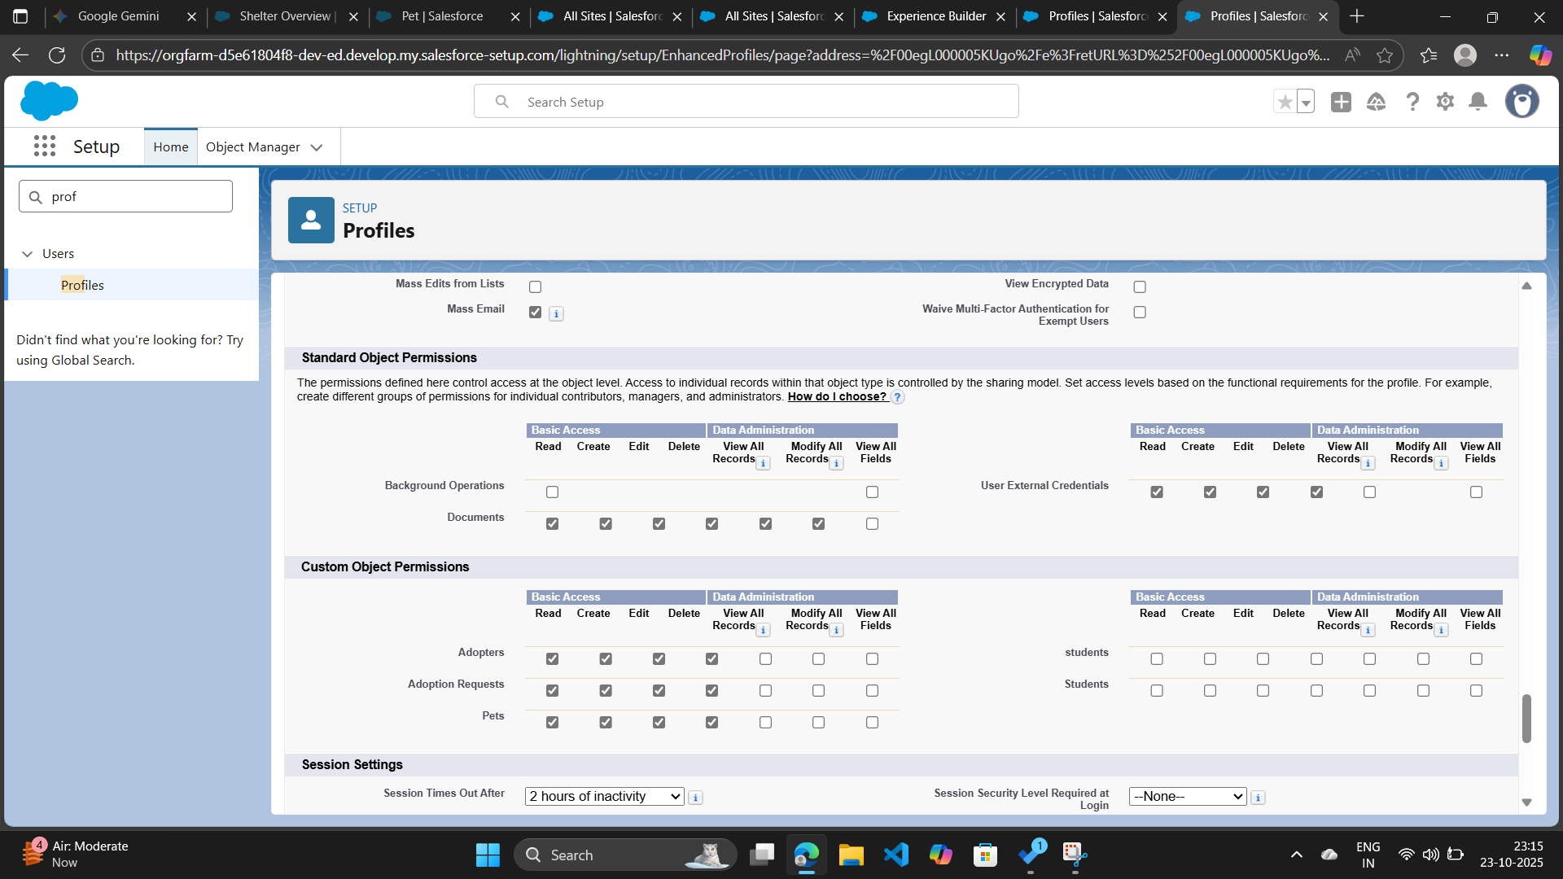

* **Building Dashboard**

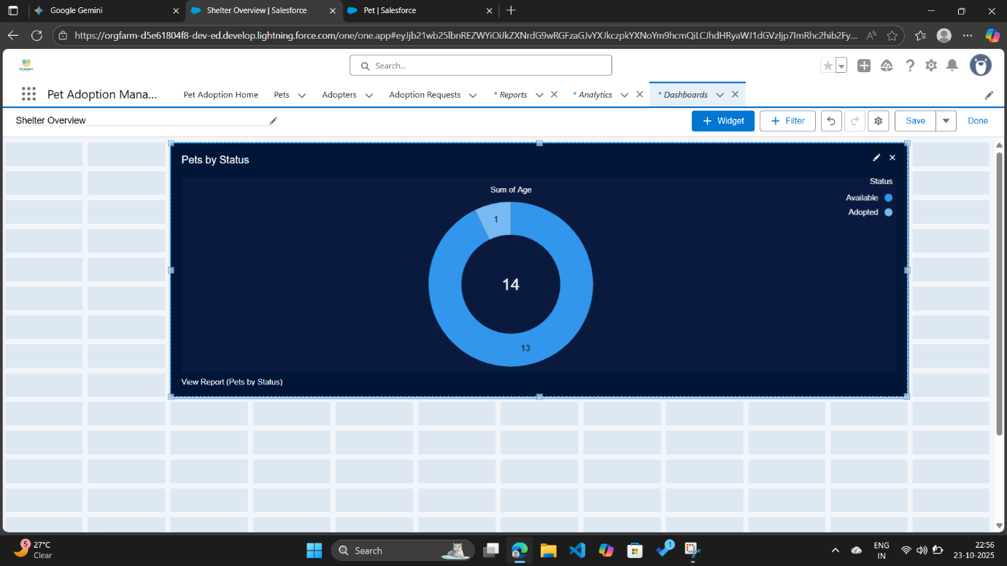

* **Creating report**

